**Experiment 4**

**Aim of the Experiment**

To Study different types of Sensors and the Interfacing of sensors to Arduino Uno and Arduino Nano Board.

**Objective**

1. To Study different types of sensors and their working with Arduino Uno.
2. To Study & Temperature , Humidity sensor (DHT11)
3. To understand the sensor and its working.
4. To use sensors for real-time applications.

**Software/Hardware Required :-** Arduino Board, USB Cable, Breadboard and Jumper wires, Temperature and Humidity sensor, Arduino IDE

**Theory**

#### Sensors are devices that detect and measure physical properties or environmental changes and convert them into signals or data for analysis. They operate based on various principles such as electrical, optical, mechanical, or chemical interactions to capture and process information from the surrounding environment. These signals are then utilized in a wide range of applications, including industrial automation, environmental monitoring, medical diagnostics, and consumer electronics. The development of advanced sensor technologies continues to drive innovation and enable the creation of smarter, more interconnected devices and systems.

**Types of Sensors**

There are various types of sensors, each designed to detect specific physical properties or environmental changes. Some common types of sensors include:

Temperature sensors: These measure the heat or coldness of an object or environment, commonly using thermocouples or thermistors.

Pressure sensors: They detect changes in pressure, often found in applications like barometers, blood pressure monitors, or industrial systems.

Proximity sensors: These sense the presence or absence of an object without physical contact, using technologies like ultrasonic, capacitive, or inductive proximity sensing.

Light sensors: Also known as photodetectors, they detect light levels or changes, commonly used in cameras, automatic lighting systems, and optical communication devices.

Motion sensors: These sensors detect movement and acceleration, found in applications like smartphones, gaming consoles, and security systems.

Humidity sensors: They measure the amount of moisture in the air or a substance, widely used in weather monitoring, greenhouses, and HVAC systems.

Gas sensors: These detect the presence of specific gases in the environment, crucial in applications such as air quality monitoring and industrial safety.

Touch sensors: They respond to physical touch or pressure, commonly used in touchscreens and interactive devices.

Magnetic sensors: These detect the presence and strength of magnetic fields, found in compasses, vehicle speed sensors, and magnetic encoders.

Chemical sensors: They react to specific chemical substances or changes in chemical composition, utilized in gas detectors, environmental monitoring, and medical diagnostics.

These sensors play a fundamental role in various industries and applications, enabling the collection of data and facilitating automation, control, and monitoring processes.

**DHT11 Sensor:**

The DHT11 sensor is a low-cost digital temperature and humidity sensor commonly used in electronics projects. It provides a simple and reliable way to measure ambient temperature and relative humidity.

It's important to note that the DHT11 sensor has relatively lower accuracy and resolution compared to more advanced sensors like the DHT22 or the SHT series. However, its low cost and ease of use make it a popular choice for basic temperature and humidity monitoring applications in Arduino projects or other microcontroller-based systems.

**DHT11 Sensor Specification:**

Here are the specifications of the DHT11 sensor:

1. Temperature Measurement:

- Temperature Range: 0°C to 50°C

- Temperature Accuracy: ±2°C

- Resolution: 1°C

2. Humidity Measurement:

- Humidity Range: 20% RH to 90% RH

- Humidity Accuracy: ±5% RH

- Resolution: 1% RH

3. Operating Voltage: 3.3V to 5.5V DC

4. Output: Digital signal (single-bus interface)

5. Response Time:

- Temperature: Within 2 seconds

- Humidity: Within 2 seconds

6. Sampling Interval: Minimum 1 second

7. Size: 23mm x 12mm x 5mm

8. Pinout:

- VCC: Power supply (3.3V to 5.5V)

- GND: Ground

- DATA: Digital data output

9. Communication Protocol: One-wire communication protocol

10. Power Consumption:

- Standby Current: < 5μA

- Active Current: 0.3mA

In the context of the specifications provided for the DHT11 sensor, "RH" refers to Relative Humidity. Relative humidity is a measure of the amount of moisture or water vapour present in the air compared to the maximum amount the air could hold at a specific temperature. It is expressed as a percentage.

For example, if the relative humidity is 50%, it means that the air is holding 50% of the maximum moisture it can hold at the current temperature. Higher relative humidity indicates that the air is more saturated with moisture, while lower relative humidity means the air is relatively drier.

The DHT11 sensor is capable of measuring relative humidity within a range of 20% to 90% RH, with an accuracy of ±5% RH. It provides a way to monitor and measure the humidity level in the environment where it is placed, which can be useful in various applications such as weather monitoring, home automation, agriculture, and more.

**Circuit Diagram:**

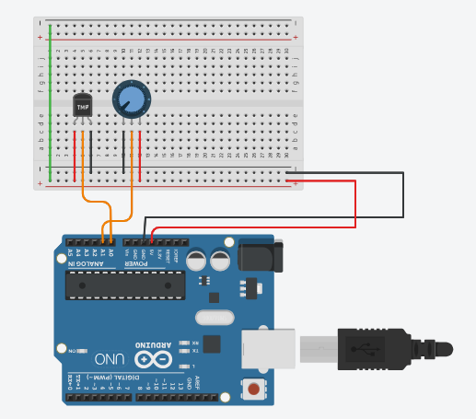

**Code Screenshot:**

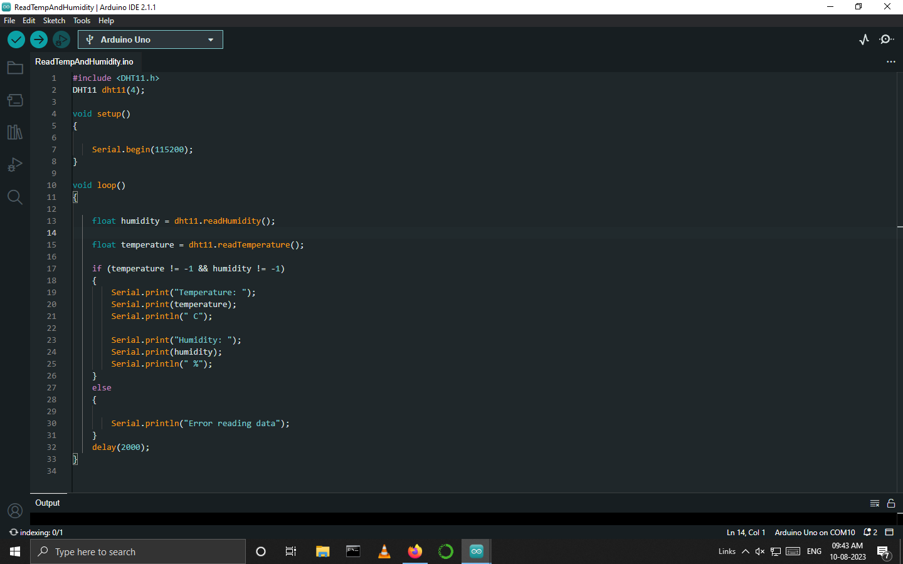

**Output:**

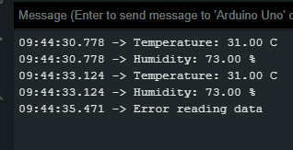

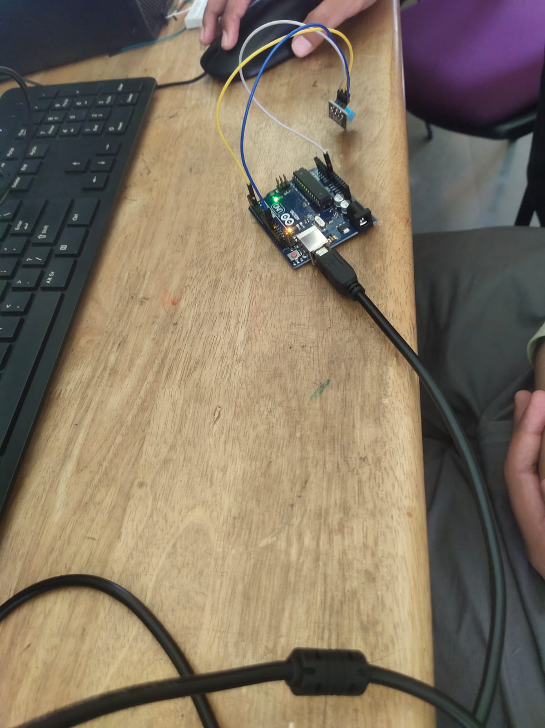

**Conclusion:** In this experiment , we understand about sensors which are essential components in modern technology and play a crucial role in various fields and applications. From detecting temperature, pressure, and light levels to sensing motion, proximity, and chemical substances, sensors enable the conversion of physical properties and environmental changes into measurable signals or data. Their diverse range of applications spans across industries, including electronics, automotive, healthcare, environmental monitoring, and more. As technology continues to advance, sensors are expected to become even more sophisticated and integrated, further contributing to the development of smarter and interconnected devices and systems. Embracing and improving sensor technologies will continue to drive innovation and enhance our understanding and control of the world around us.